A512002211
Metal 30/40/50 說明
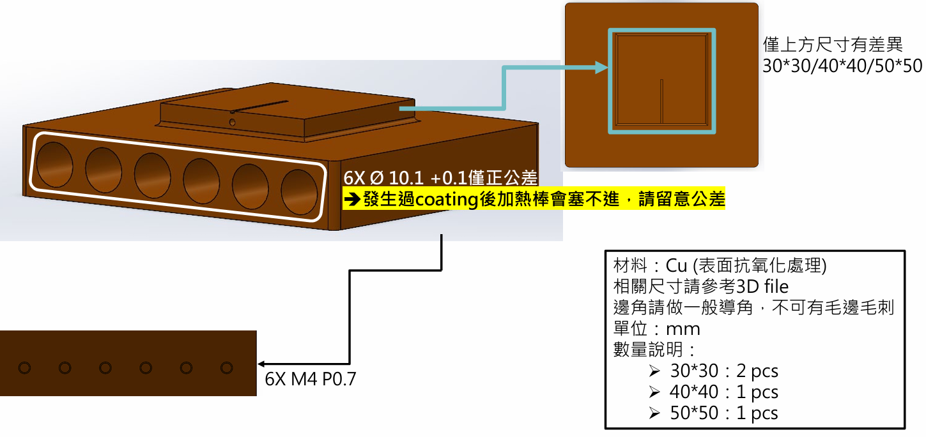

Dummy heater- top、top_cus_A


